**Goal: Develop a database to analyze and visualize Hotel Booking Data**

**Questions:**

1. Is our hotel revenue growing by year?
2. Should we increase our parking lot size?
3. What trends can we see in the data?

**Steps:**

1. Build a database
2. Develop the SQL Query
3. Connect Power BI to the Database
4. Visualize
5. Summarize findings

**Find the dataset here under the Hotel Revenue Dataset:**

<https://absentdata.com/data-analysis/where-to-find-data/#google_vignette>

**Using SQL Server to build a database:**

SQL statements 1:

Result set 1:

**Develop the SQL Query:**

SQL statements 2:

Result set 1:

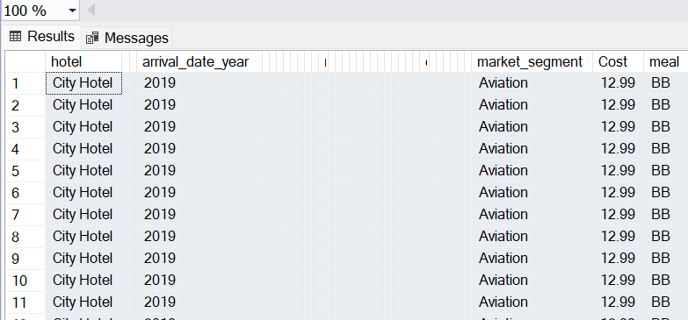

**Connect Power BI to the Database:**

Pasting the SQL statements 2 in new database:

Creating a new column as Revenue in the Edit Query window in Power BI

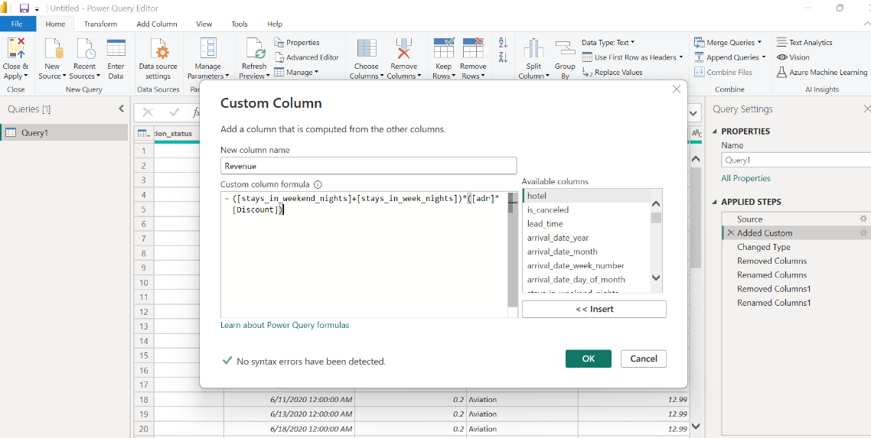

**Visualize and Summarize Findings:**

View the results in the exercise file: [Hotel Revenue.pbix](Hotel%20Revenue.pbix)